
We’re Going to Lisbon!
World Gymnaestrada 2027
Woden Valley Gymnastics Club Information Guide
Event Overview
Woden Valley Gymnastics Club (WVGC) is proud to be joining the Australian Team for the 2027 World Gymnaestrada in Lisbon, Portugal, marking our third participation in this extraordinary international event.
The World Gymnaestrada is the world's largest non-competitive gymnastics festival, held every four years and organised by the Fédération Internationale de Gymnastique (FIG). The event celebrates movement, creativity, cultural exchange, and global connection, welcoming participants of all ages and abilities.
The 2027 Event Will Feature:
- Group performances
- National performances
- City displays
- Mass participation events
- International evenings
- Gala performances
More than 22,000 athletes, supporters, coaches, officials, and volunteers are expected to attend.
For more detailed information, please refer to Gymnastics Australia's official bulletins and the World Gymnaestrada website. While much of the information is directed towards clubs managing teams, it still provides valuable insight into the event.
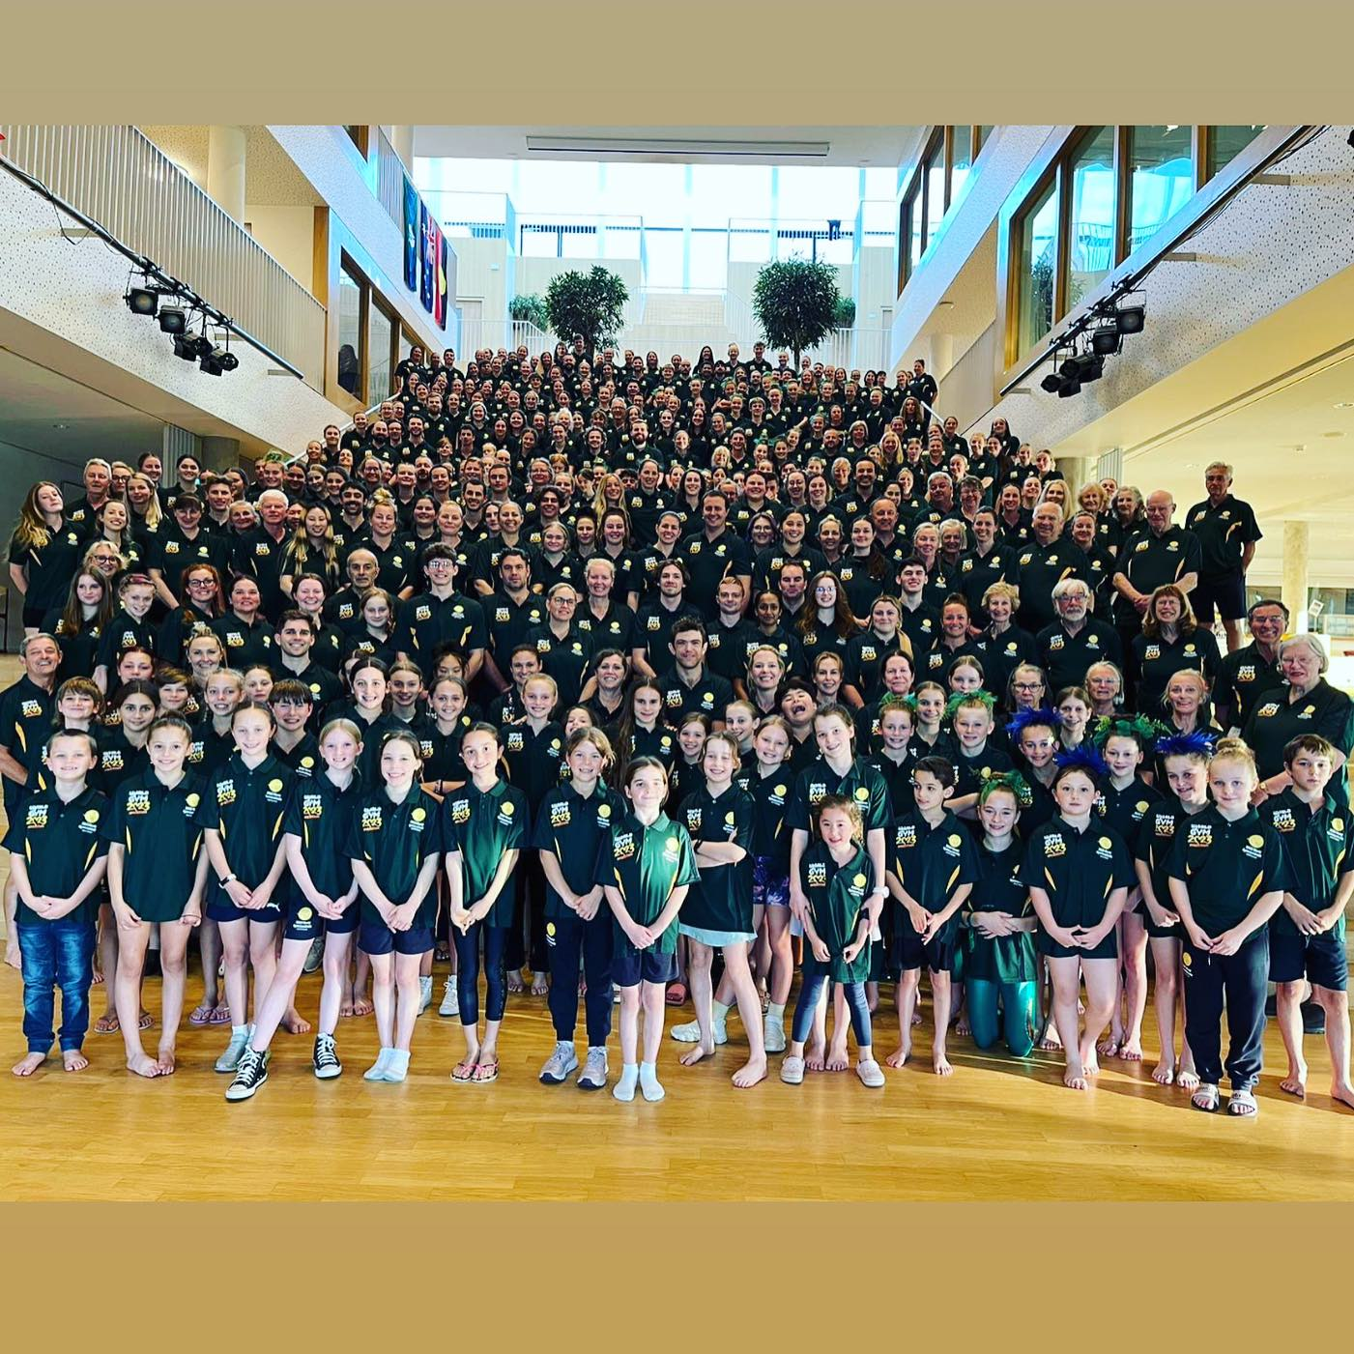
Team Australia, Gymnaestrada Amsterdam 2023
WVGC Teams
WVGC will be taking two teams to Lisbon. Current members, former members, and non-members are welcome to express their interest.
Groove and Move Gala Team
(Approximately 50 years and over)
This team has been selected to represent Australia in the prestigious World Gymnaestrada Gala Performance.
The Gala is one of the feature events of the festival and is performed in a major arena before thousands of spectators. Selection is a rare honour and provides participants with a truly world-class performance experience.
Team members will also participate in additional outdoor performances throughout the event.
Travelling as a chaperone for the Open Team? Consider joining the Groove and Move Team and experiencing Gymnaestrada as a performer rather than a spectator.
Open Team
(Ages 5 years and above)
The Open Team welcomes athletes who are enthusiastic about training and performing as part of a large and dynamic team.
Requirements include:
- Ability to follow instructions and work as part of a group
- Commitment to regular training attendance
- Positive attitude and willingness to perform
The Open Team will participate in:
- Three hall performances
- Outdoor performances
- The Australian World Team Performance
Athletes will also have countless opportunities to watch performances from around the world and immerse themselves in the unique Gymnaestrada experience.

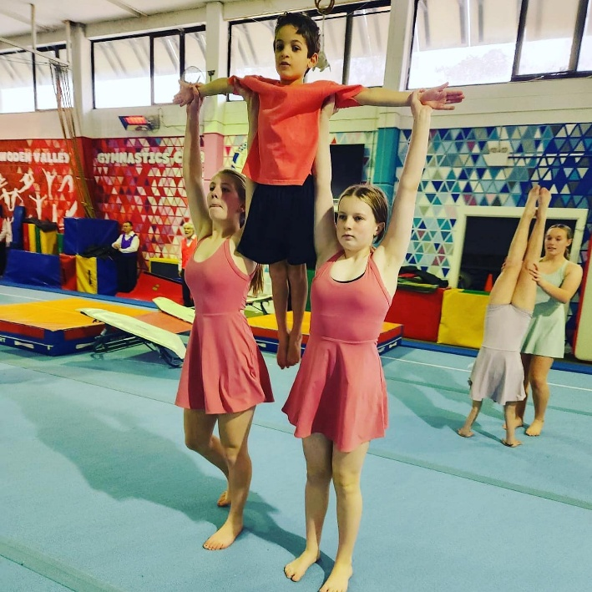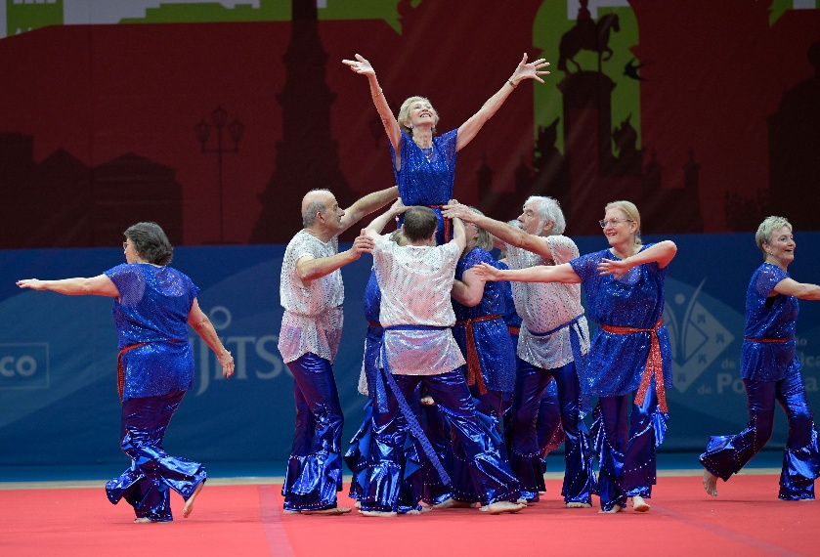

Expression of Interest (EOI)
- A non-transferable Expression of Interest (EOI) payment of AUD $300 is required by 10 June 2026.

- The EOI payment is refundable only until WVGC makes its first payment to Gymnastics Australia, anticipated to occur from mid June 2026.
- A definitive entry deposit of AUD $350 due 25th June 2026 to be debited from your iclass pro registered account.
- For EOI registration and payment use the following link:
https://portal.iclasspro.com/wodenvalleygymnasticsclub/camp-details/524?typeId=39&filters=%7B%22sorting%22:%22time%22%7D&campTypeName=Gymnaestrada%20Expression%20of%20Interest%20(EOI)&campTypeNamePlural=Expression%20of%20Interest%20(EOI)

Training Commitments
Training schedules are available via the team-specific training documents.
Groove and Move:
https://docs.google.com/document/d/1WJMFMxwPBOGxVK7TokzVdBehxIfNLI9yQSAbTbvIQj4/edit?usp=sharing
Open Team:
Open Team Gymnaestrada Training Schedule
Official Training Period
July 2026 – July 2027
All team members are expected to:
- Prioritise Gymnaestrada training commitments
- Attend scheduled training sessions regularly
- Communicate absences in advance where possible
- Notify coaches prior to training if absent due to illness

Consistent attendance is essential to ensure routines progress safely and achieve the standard required for an international event.

Eligibility and Compliance
Membership Requirements
Athletes do not need to be current WVGC members to express interest or be selected.
However, all participants must hold a current WVGC membership from the commencement of training through until the conclusion of the event. If you are a member of another club, we can arrange a multi club membership through Gymnastics Australia.
Passport Requirements
All athletes and chaperones must hold a valid passport with a minimum of six months validity beyond July 2027.
Integrity Requirements:
All persons over the age of 16years must hold an ACT Government Working With Vulnerable Card or interstate equivalent.
Team Expectations
Failure to comply with:
- Club policies
- Training commitments
- Payment agreements
- Behavioural expectations

may result in removal from the team.

Travel and Event Dates
Independent Travel
Participants not travelling with the WVGC group may commence personal travel following the final dress rehearsal on 26 June 2027.
Chaperoned Team Travel Option
London Program
1–6 July 2027
The optional WVGC pre-event program includes:
- Accommodation
- Breakfast daily
- Guided sightseeing activities
- West End show
- Harry Potter Studio Tour
Portugal Schedule
Date | Activity
6 July | Arrive in Lisbon (by 12:00pm - TBC)
6–10 July | Australian Team Training Camp (Compulsory)
11–17 July | World Gymnaestrada
18 July | Departure from official accommodation
Post Event
Participants may:
- Return to Australia, or
- Continue independent travel arrangements.

Accommodation
Australian Team Accommodation
Participants will be accommodated with the Australian Team in school based accommodation.
This includes:
- Dorm Room Accommodation
- Shared Bathroom
- Airbed
- Sleeping Bag
- Basic pillow
- Daily breakfast

Accommodation is typically located close to event venues and public transport.
Hotel Accommodation
Hotel accommodation may be available in exceptional circumstances for genuine medical reasons or if you are on the Groove and Move Team
Any hotel arrangements:
- Must be approved by the WVGC Team Manager and or Gymnastics Australia
- Are not included in Gymnastics Australia package costs
- Will incur additional charges

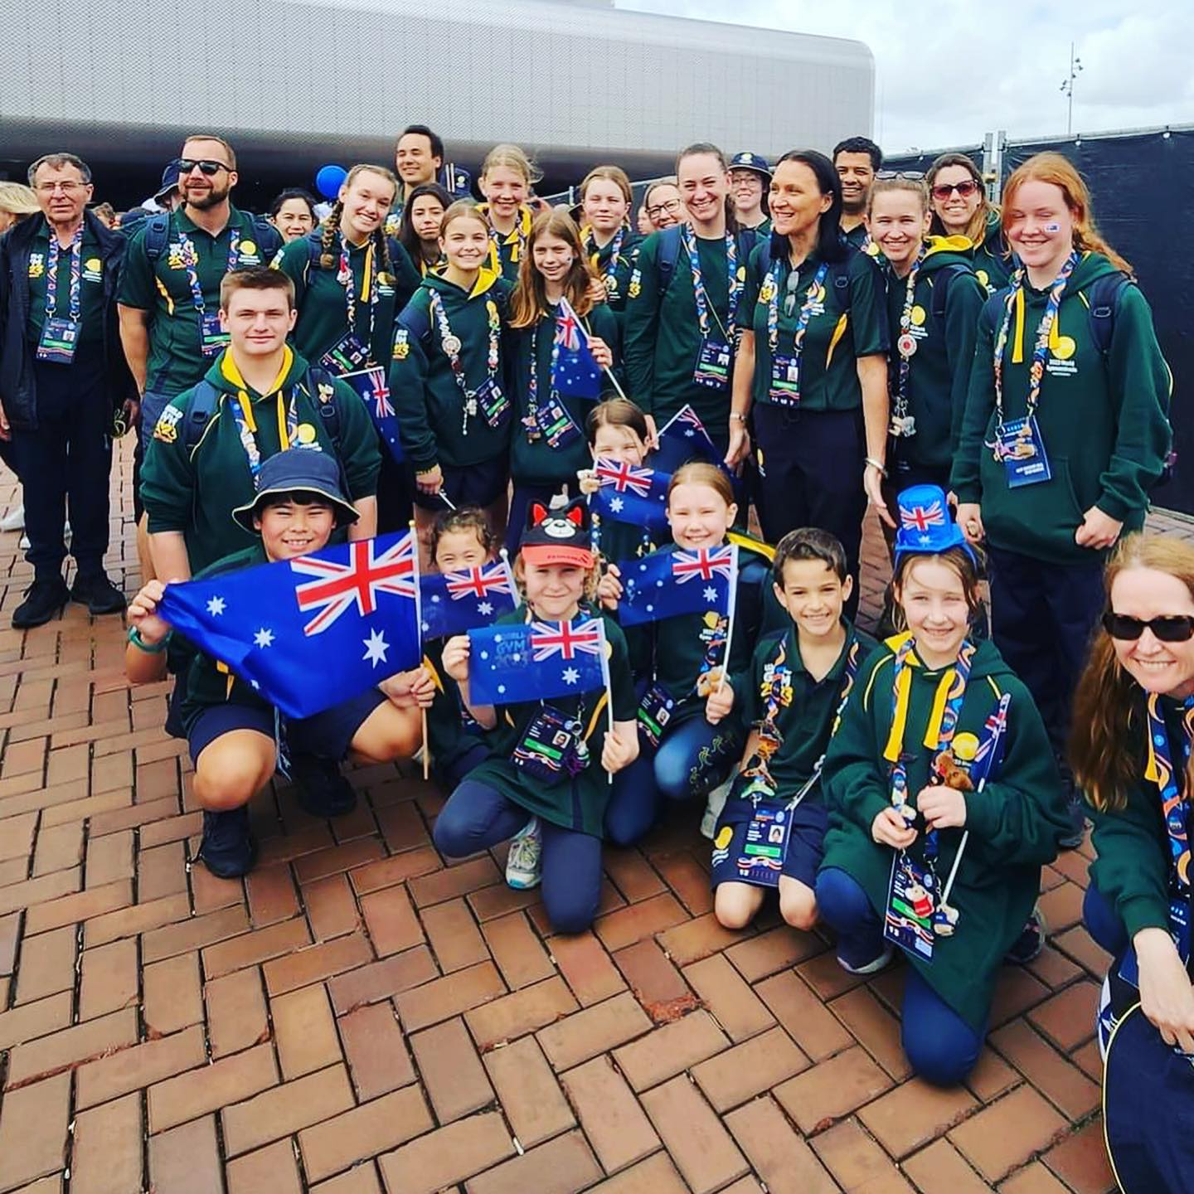

Indicative Costs (AUD)
Gymnastics Australia Package
Approximately $2,650
Includes:
- Event registration
- Accommodation
- Public transport pass
- Insurance
- Breakfast and lunch during the event
- Bedding package
- Australian Team uniforms
- Australian Team Training Camp
- OGU Team contribution
WVGC Costs
Approximately $700
Includes:
- Club support levy
- Performance costumes
Fundraising efforts may reduce final costs.
Chaperoned London Program
Flights
Approximately $3,200
Includes:
- International flights
- London to Lisbon flight
London Program
Approximately $1,300
Includes:
- Four nights accommodation
- Breakfast
- Tours and activities
- West End show
- Harry Potter Studio Tour
Additional Costs Not Included
Participants should budget separately for:
- Travel insurance
- Personal spending money
- Optional sightseeing
- Gala tickets
- International evening tickets
- Hotel accommodation (if applicable)
- Flights (for participants not travelling with the club group)

Please refer to the WVGC Payment and Refund Policy for detailed payment plan information:
https://www.wodenvalleygymnastics.com.au/world-gymnaestrada-2027
Fundraising
Fundraising participation is expected from all team members.
Examples may include:
- Bunnings BBQs
- Raffles
- Babysitting nights
- Product sales and fundraising drives
New fundraising ideas are always welcome.

Chaperoning Information
Athletes Aged 12 Years and Under
Must:
- Have a dedicated adult chaperone (18+)
- Stay with their chaperone in team accommodation
- Have all required Working With Vulnerable People (WWVP) clearances completed

The same chaperone must remain responsible for the athlete throughout the event.

Athletes Aged 13–17 Years
Will be supervised by club-appointed chaperones from the time they enter the Clubs care.
Where family members are attending as supporters, athletes may spend approved time with family outside official commitments, subject to approval from the Team Manager or Lead Chaperone.
Supporters
Family members and friends are welcome to attend the event as supporters.
Supporters are responsible for arranging and funding their own:
- Flights
- Accommodation
- Event tickets
- Travel insurance
- Etc.

Team Communication
The primary communication platform for the team will be:
Stack Team App
Parents/guardians and athletes aged 12 years and over will be required to join the team communication group.
Additional communication methods may include:
- Email
- Face-to-face meetings
- WhatsApp groups
- Printed information

Personal information collected throughout the project will be stored securely and used only for official Gymnaestrada purposes.
Photography and Video Consent
Photography and videography are an integral part of the Gymnaestrada experience.
By participating in the team, participants acknowledge and consent to the use of photographs and video recordings by:
- Woden Valley Gymnastics Club
- Gymnastics Australia
- The World Gymnaestrada Organising Committee

This may include promotional, educational, historical, and media purposes before, during, and after the event.

Important Note
The information contained within this document was accurate at the time of publication.
As planning for World Gymnaestrada 2027 continues, details may change based on information provided by Gymnastics Australia, the Organising Committee, travel providers, and other external stakeholders.
WVGC will endeavour to communicate any updates or changes in a timely manner.
Contact:
For more information, please contact Naomi Nye the team manager via email
naomi@wodenvalleygymnastics.com.au

